Anesthesia Core Focus Measures
- Pulmonary
  - Maintain Tidal Volumes below 8 mL/kg
    - Check Reference Cards
- Blood Transfusions
  - Post transfusion Hemoglobin and hematocrit value less than 10/30
    - Draw Pre- and Post H/H
- Temperature Maintenance
  - Document core temperature intraoperatively
    - Skin sources DO NOT count

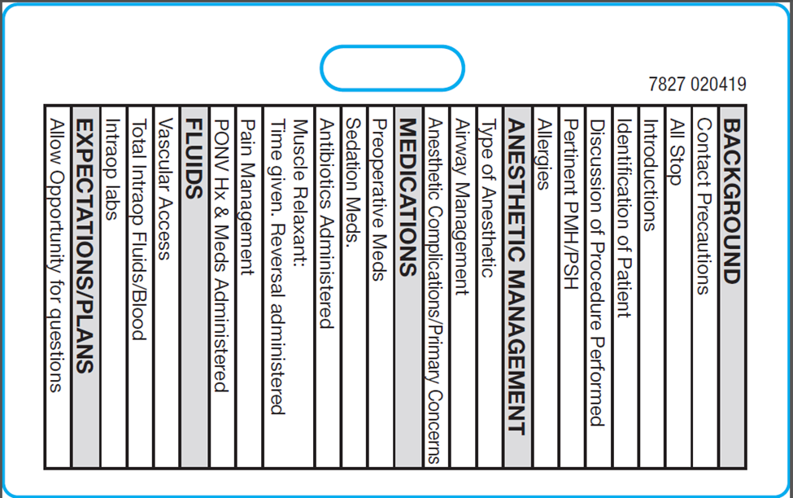
Anesthesia Core Focus Measures
- Pulmonary
  - Maintain Tidal Volumes below 8 mL/kg
    - Check Reference Cards
- Blood Transfusions
  - Post transfusion Hemoglobin and hematocrit value less than 10/30
    - Draw Pre- and Post H/H
- Temperature Maintenance
  - Document core temperature intraoperatively
    - Skin sources DO NOT count

