

MPOG App Suite - Frequently Asked Questions and Troubleshooting Guide

Table of Contents
User Guides 3
Data Flow 3
What credentials are required for fulfilling the different roles for MPOG Participation? 4
Anesthesia CPT Prediction Tool 5
Downloading the MPOG App Suite 6
Variable Mapping 7
Concept Browser 8
Location Mapping 9
Case Viewer 10
Data Diagnostics 11
Case Validation 14
Transfer to MPOG Central 17
Maintenance Schedule 20
Upgrades 21
Appendix A – Database Roles 22
Appendix B – MPOG Role Assignments 23
Glossary 27

User Guides
The user guides for the MPOG Application Suite can be found on our website. They are updated as needed during each MPOG upgrade, biannually in the Spring and Fall.

Data Flow

How does the data get from our Electronic Health Record (EHR) to MPOG?
Files are generated by extracting data from its source system and placed into a file share that is accessible by the MPOG Import Utility (extract). This includes data from the EHR, Anesthesia Reporting Server, the Billing Vendor, and any supplemental extracts that the site is using. Those files are removed from the file share and inserted directly into the Import Manager Database (import). The files stored in Import Manager are parsed into tabular data and inserted into staging tables (consume). This generates metadata regarding variable usage that is used in Variable Mapping. The tabular data is then inserted into the designated MPOG_MAS database (handoff).
All data up to this point is stored on the site’s local servers, MPOG does not have access to this data. Once the data has been cleaned and validated by the local team (ACQR, Quality Champion, Anesthesia IT Champion, etc.), the data can be transferred to the MPOG Central Repository by using the transfer utility within the MPOG Application Suite (upload).

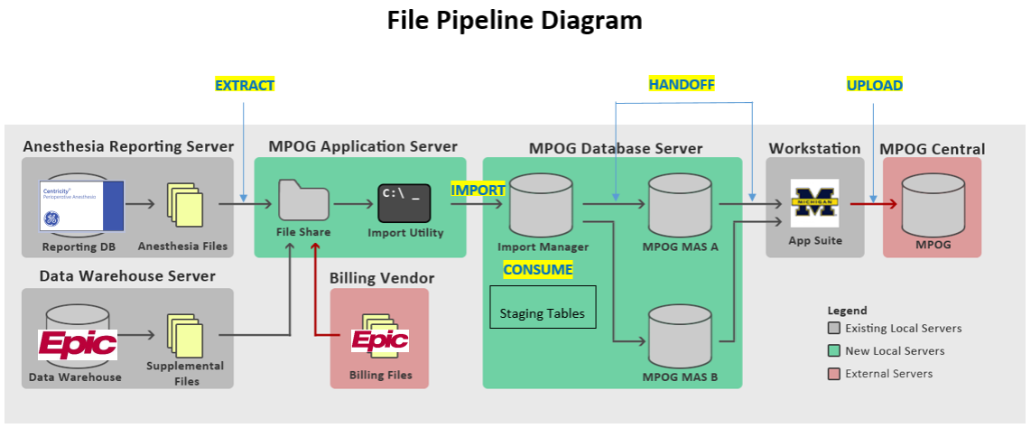

What do I do when the file is too big to import? Should I split it into multiple files?
You cannot “split” files. All that does is overwrite data since the system assumes the date you are importing is complete. You will need to re-extract the affected dates into smaller ranges, keeping individual files under 2GB in size.
- Target Date Completeness: Files cannot contain updates for only a few cases or patients at a time. Whenever data for a particular target date and module is extracted, all data for that date must be present in the file. Any data that was extracted previously but is not present in a new file will be interpreted as deleted and will be purged from Import Manager. (see MPOG Import Manager File Spec, page 5).

What credentials are required for fulfilling the different roles for MPOG Participation?
See Appendix B – MPOG Role Assignments for a breakdown of role responsibilities and requirements.

Anesthesia CPT Prediction Tool
The Anesthesia CPT Prediction tool is a machine learning algorithm that takes procedure text and predicts the top 3 anesthesia CPT codes based on cases that have submitted CPT codes. Some of the most common reasons for using the CPT predictor are:
- Billing was not completed at the time of transfer to MPOG – MPOG allows a 3-month grace period for billing to be completed and submitted
- No billing data available for a case
- A site is experiencing issues with their billing files – can be due to errors encountered during the import-consume-handoff process, errors in the billing file received from the vendor, or missing billing files
Sites still need to submit CPT codes once they are available. This tool is better than having no CPT codes but is not perfect. The tool ‘learns’ from the submitted codes to improve its predictions. Using the predicted codes will allow MPOG to send more accurate measure feedback while the site is working through the issues with the billing data.
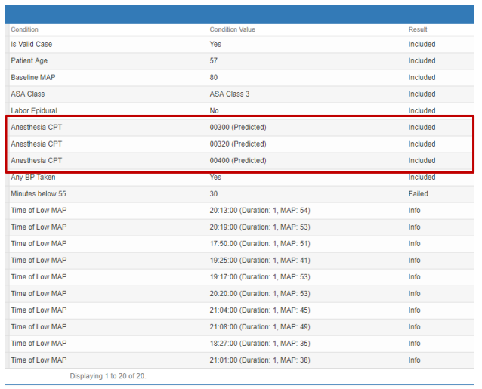

Algorithm for Selecting from Top 3 Predicted Codes:
- If difference in predicted confidence interval is >1.6x between 1st and 2nd code, Use 1st code only For example: (01922: 70%, 00700: 20%, 01936: 10%)
- If difference between predicted 1st and 3rd code is >1.6x, use 1st and 2nd code only
- For labor epidural and c-sections, use 1st predicted code only
- Machine continues to ‘learn‘ as codes are submitted – Sites will provide us feedback that will allow us to manually improve the algorithms.

Downloading the MPOG App Suite
Instructions for downloading the MPOG App Suite can be found on our website. It is not compatible with Macs and is only available for PCs. However, if you have remote access to a PC, you can download the MPOG App Suite to the PC and then connect remotely via Mac.

How do I know what information to put in to the ‘Connection Profile’?
Contact your local technical team for the server and database connection information.

What do I do if my connection fails?
- First, double check the server connection information with your local technical team
- Next, verify that you have been granted the appropriate access. See Appendix A – Database Roles. The MPOG technical team can provide instructions on which database roles should be granted. Your local technical team grants the correct roles.
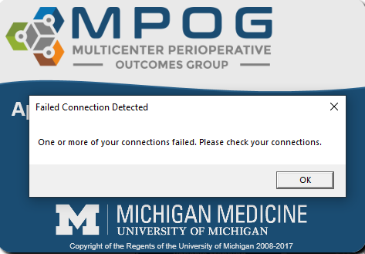

Why don’t I have access to all of the buttons? I believe I need access to some more of the apps.
- App access is done through assigning ‘Database Roles.’ These are assigned by your local technical team with some guidance from the MPOG Coordinating Center.
- Your technical team may need to grant additional ‘database roles’ if current access is not sufficient.

Variable Mapping

Is there a recommended order for completing Variable Mapping?
- We recommend mapping variable in these categories first: Race, Gender, Ethnicity, Procedure Service, Admission Type, Staff Type. These categories typically have less variables and can be mapped quickly.
- Next, we recommend mapping variables in the Lab Type and Administration Type (Inputs/Outputs/Meds) categories.
  - There are 3 steps in completing Lab Type mapping.
    - Start with mapping labs that are important to surgical/anesthesia care (Hgb, Hct, Creatinine, Glucose, Troponin, potassium).
    - Next, map microbiology and virology labs that we have concepts for (i.e., coronavirus, COVID Antibody testing, blood cultures, wound cultures, etc.)
    - Finally, map any remaining labs that we have concepts for (i.e., WBC, blood gases) .
    - If we do not have a concept for a variable, it is okay to leave it unmapped or skipped.
  - The Administration Type (Inputs/Outputs/Meds) category includes IN’s and OUT’s such as fluids, medications, blood products, EBL, emesis, and urine output. Exclude all physiologic and gas flow variables from this mapping group. Epic sites, exclude all “volume (mL)” medication variables, as they are duplicates.
- The bigger categories, Administration Route, Units of Measurement (Administration), Observation Type, and Observation Detail Type should be mapped last.
  - When mapping Administration Route, map unspecified concepts to “Other” or leave unmapped. Focus on completing mapping for variables with a row count greater than 100. Units of Measurement (Administration), leave those variables without a corresponding MPOG concept unmapped. Observation Type includes the events, physiologic, and outcomes variables (i.e., intubation). This category should be mapped before Observation Details Type, which includes variables that are the details of the events (i.e., ETT type). For both Observation Type and Observation Details Type, we recommend starting mapping by focusing on variables with a row count greater than 1000, then focusing on any that are specific to anesthesia and surgical care.

What is Premapping?
Premapping is completed by the MPOG Coordinating Center for Epic sites only, since Epic often uses similar variables across their sites. MPOG will review the common Epic AIMS IDs and update the pre-mapping for these variables. This occurs automatically when a new Epic site starts onboarding with MPOG. After onboarding is completed, premapping updates can still be applied and reviewed by clicking on the Premappings button in Variable Mapping. The ‘Variable Mapping Tips - Epic Sites’ user guide on our website has more information about the premapping process.

What if there are multiple variables with similar names?
If duplicate variables exist for critical times such as anesthesia start/end, surgery start/end, etc., anesthesia documentation is preferred but you can also map nursing documentation if anesthesia documentation is not available for critical times/events.

How do I know what types of variables should be mapped to the concepts that have similar names?
We have added definitions to some of our concepts to clarify their intended use. These concepts will have a blue icon next to it on the right side of the Variable Mapping tool. Hover over the icon, and it will give you more information about that concept. If you have a question about a concept that does not have an icon, contact the MPOG help desk (support@mpog.zendesk.com).
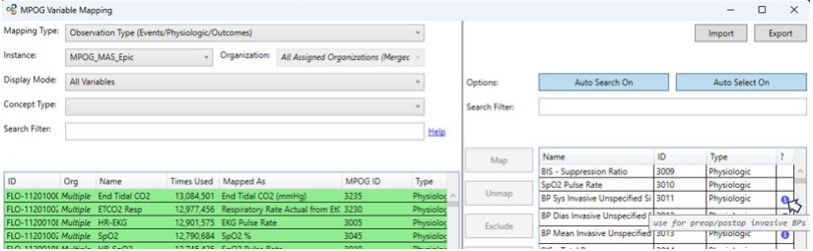

Concept Browser

Why do concepts not come up when I search by concept ID?
To search by concept ID, type ‘id:’ before the numbers
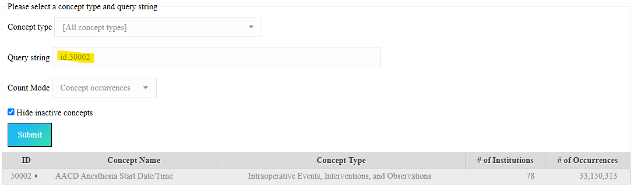

Location Mapping

How do you determine what the Health System name is?
For institutions within the United States, we use the American Hospital Association (AHA) website to determine Health System names for all MPOG participating sites. This allows for standardization in aggregate reporting and enables future analysis for research projects at the hospital and/or health system level. If a hospital is not part of a larger health system, then the hospital name is assigned as the health system name also. This is done during Clinical Onboarding, and the MPOG Clinical Informatics Specialist will assist with assigning location names and types.
If your institution changes names, contact the MPOG help desk (support@mpog.zendesk.com), and we will work with you to update the names together.
For institutions located outside of the United States, we will determine this together to ensure standardization in naming across participating sites.

How do you determine if a location is a hospital or subsidiary hospital?
For institutions within the United States, we also use the American Hospital Association (AHA) website to determine if a location is a hospital or subsidiary hospital. This is done during Clinical Onboarding, and the MPOG Clinical Informatics Specialist working with you will help with the location names and types.
For institutions located outside of the United States, we will determine this together using the information that is available.

Can we add locations to MPOG that were previously not included?
Yes, you can add more locations after you are in MPOG production, however additional validation is required before upload. Please contact the Coordinating Center for guidance as you consider adding new locations to ensure the following steps are addressed:
- Fill out the MPOG Application for existing sites adding new locations
  - The application does not allow you to save and return later and must be completed in one session.
  - For sites outside of Michigan, additional fees may apply. For more information regarding fees, please visit the MPOG Website: https://mpog.org/funding-outside-michigan/
- Once we receive the application, MPOG will follow up via email with the next steps.
- Do NOT enable any new locations until after you receive instructions from MPOG.

Case Viewer

I can see information in my EHR (Epic, Cerner, etc.) that I do not see in Case Viewer. Where did the information go?
- First, try searching for the variable in ‘Record Search.’ If it appears, look to see what the original variable is mapped to. Fix any incorrect mapping in ‘Variable Mapper.’
- If unable to find in ‘Record Search,’ check table view for the variable. Again, see if there is any mapping that needs to be corrected.
- If variable is not in ‘Table View,’ check Variable Mapper. The variable may have been inappropriately excluded. Correct any mapping issues found.
- If variable is not in Case Viewer or Variable Mapper, contact your local technical team with a case example, screenshots of the data in your EHR, and any other relevant information. The data may not be part of the data getting extracted from your EHR.

Data Diagnostics

How is Data Diagnostics Used?
Data Diagnostics is used to help verify data completeness, variable mapping, and accuracy. Two separate strategies are employed to improve data quality and ensure data accuracy. Technical and clinical staff use this tool to detect systematic errors with data extraction, transformation, or mappings. Diagnostic visualizations represent specific pass/failure thresholds to determine compliance at a macro level. If one (or more) diagnostics for your site fall in either the Borderline or Poor areas, complete a data drill down to determine what is causing the result. Borderline or Poor results tend to be related to any combination of the following issues:
- Data missing and not included in the extract
- Errors somewhere in the Import Manager Data Flow process
- Handoff has not finished
- Variable Mapping: mis-mapped variables, unmapped/skipped/excluded variables, recent mapping changes
- Documentation at the site (i.e., Train of Four is not routinely documented)

Billing Diagnostics
Some diagnostics are required for all sites, some are optional, and one is only required for Epic sites. The chart below breaks this down.

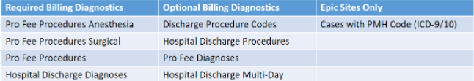

My case has billing codes, why is it failing the billing diagnostic?
Hospital Discharge data is linked to the patient. The diagnostic requires the associated billing code to align with the case time. (The billing code start and end times must include the case time period).
Professional fee diagnostics require the codes be case linked. If you are seeing codes for the date of the procedure, but they are not marked as case-linked, do your pro fee codes have a time component? You can set an import manager handoff setting that increases the tolerance for case linking. This can be set in the Import Manager Assistant app, contact support@mpog.zendesk.com for assistance.

How often should I review Data Diagnostics?
Data Diagnostic review and attestation are required for all sites before uploading to the Central MPOG database. All funded sites are required to conduct this attestation process on a monthly basis. Non-funded sites are required to complete attestation before each upload to MPOG Central. If submission is on a monthly basis, then attestation should also occur on a monthly basis.

How do I drill down on a diagnostic?
See Data Diagnostics Troubleshooting guide.

What can cause a sudden dip or spike in the Data Diagnostics scores?
There are multiple reasons why you see sudden dips or spikes in your data. Some of the most common reasons are:
- Possibility 1: Changes in clinical practice that are accurately reflected in the data.
  - In this example, an initiative was rolled out at a site in May/June 2019 to improve EBL documentation.
  - As expected, the percentage of cases with EBL documentation increased after the initiative.
  - This diagnostic is reflective of practice at the institution and can be attested as accurate.
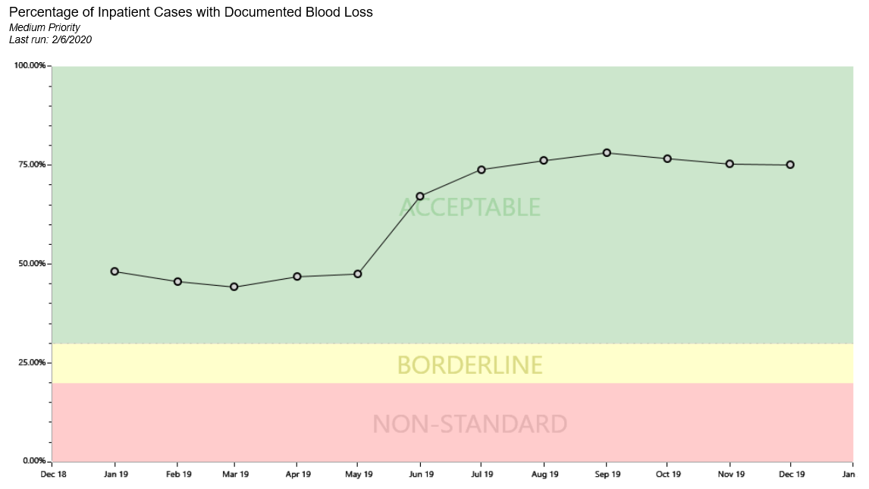
- Possibility 2: Mapping changes
- Possibility 3: New concepts that need mapping
- Possibility 4: Extract changes
- Possibility 5: Location name changes in the Extract

What does it mean to complete ‘Data Diagnostic Attestations?’
In the Attestation section, the site Anesthesia Clinical Quality Reviewer (ACQR) or Quality Champion can review the diagnostic and determine if the data accurately represents the documentation present at the site (either in the EHR or billing software). You can attest to the accuracy of your data multiple times throughout the month, but Attestation is required to be completed for all diagnostics labeled as High Priority and Medium Priority at least once per month prior to upload to MPOG Central.

Case Validation

Why does the question ask if the patient was 90 years old when they were older?
MPOG cuts age off at 90 years old to decrease the chance that the patient could be identified, since most of the patients are younger than 90. When you see a question asking if the patient was 90 years old, but they were actually older, you should answer ‘Correct’.

Why does the date and time of operation show up as 01/01/0001 - 00:00?
The data for this case has not yet finished handoff. You can either choose another case to validate or save the MPOG Case ID and try to validate the case again in a few days after handoff is complete. Check Import Manager Assistant to assess the handoff queue (see Module: Data Review – IM Assistant.
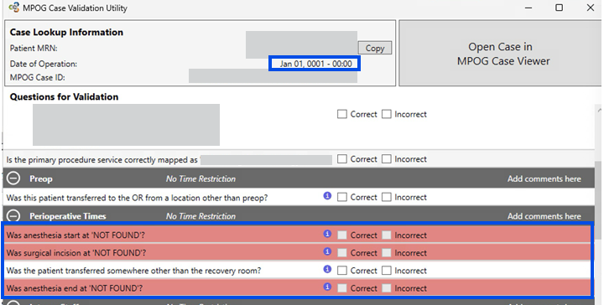
*Case Validation uses Anesthesia Start Date/Time as the Date of Operation in the banner for all unreviewed cases. If a case is reviewed that has Anesthesia Start Date/Time missing, it will default to Scheduled Time as the Date of Operation until the issue causing the missing anesthesia start time is resolved.

Why does it say, ‘Was surgical incision NOT FOUND’ and the line highlighted in red?
There are different scenarios that may result in ‘surgical incision not found’:
- If you are reviewing a procedure where there is no incision (i.e., labor epidural), this is expected, and you can skip the question.
- If you are reviewing a case where you would expect to see an incision (i.e., CABG) and it is highlighted red
  - First, check Variable Mapping. The incision time may be unmapped, or it may be mapped to a different concept. This question looks for variables mapped to either 50006 AACD Procedure Start Date/Time or 50235 Surgical Incision Time.
  - If the mapping is correct, then review Import Manager Assistant to verify that handoff has completed. Rever to the Import Manager Assistant user guide for instructions on how to check handoff status. If it has completed, review Import Manager Assistant for missing days and contact your local Technical Support person to help troubleshoot. Contact the MPOG help desk (support@mpog.zendesk.com) if further assistance is needed.

Where does MPOG get the admission information from?
Case Validation Question: ‘Is the admission type correctly mapped as ___?’
This question pulls data from the preop admission status, or what the admission status was when the case was booked. We have developed a specification for an optional supplemental extract for ADT (Admission/Discharge/Transfer) data that can be used to show admission status changes. Contact the MPOG help desk (support@mpog.zendesk.com) if you are interested in submitting this optional extract.

Case Validation says that the patient had a block, but it is from a prior procedure.
Sites that use Epic have seen this issue. Usually this is due to documentation, where the block is documented as an LDA during a prior procedure but is never documented as removed. Since it was not removed, it looks like the patient still has it. We have phenotypes that can address this issue once you transfer to MPOG Central, however we cannot apply phenotypes on your local database. The way to fix this issue is to address the documentation. Otherwise, you can answer this question as ‘Correct’ because it accurately reflects the documentation in your EHR.

How does MPOG determine if a medication is a bolus or an infusion?
This is determined by site documentation, but the medications that MPOG typically expects to see as boluses or infusions are listed in the table below.
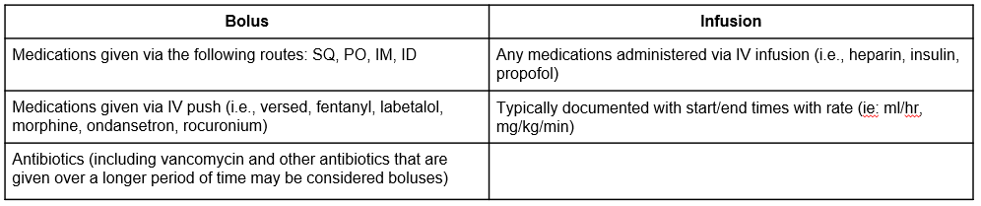
If an end time is not populated, infusion dose will continue until the start time of the next administration for the same medication. If an end time is not populated and there is not an additional administration, the infusion will continue until anesthesia end time. If the infusion start time is after anesthesia end, the end time will default to 5 minutes after infusion start.

Why does Case Validation ask the same intraop medication question multiple times?
Case Validation is used to confirm your site’s variable mapping. Intraop medication question logic is as follows:
- The first medication alphabetically
- The last medication alphabetically
- The heaviest medication by mass
- The lightest medication by mass
If the same medication question is repeated, it’s likely due to one of the following reasons:
- The case was a small/short case with only a few medications administered and therefore that one medication meets the criteria for the questions listed above.
- There may be unmapped medications that were administered in the EHR but do not show up in Case Viewer. Please review variable mapping if this is the case.

How is the infusion end time determined if it wasn’t documented in the EHR?
Case Validation defaults infusion end time to 6 hours after anesthesia end if it was not documented or if it was documented later than 6 hours after anesthesia end. The standard extract timeframe for MPOG data is limited to 4 hours before anesthesia start through 6 hours after anesthesia end. Some sites may have modified their extract timeframe – contact your technical team if you have questions regarding the extract.

My patient had many labs resulted in the time frame asked, but the questions only ask about hemoglobin, hematocrit, and glucose. Is that right?
The questions under the labs section are looking for only hemoglobin, hematocrit, and glucose labs from the day before through the day after the procedure. It will not look at any other labs during this time frame.

What do I do when Case Validation doesn’t match what I see in the EHR?
See Case Validation Troubleshooting guide.

Transfer to MPOG Central

How long after I transfer my data will it be updated on the dashboard?
On the 1st, 2nd, and 4th week of each month, data is processed at MPOG Central in the order it is received. During transfer week, which is the 3rd week of the month (2nd week in December), the data is processed so that the newer cases are completed first. This is to allow for the most recent data to be completed and ready for provider feedback emails to be sent the following Wednesday.
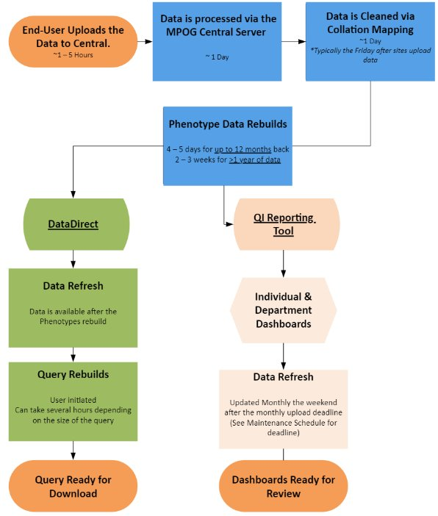

What is Privacy Preserving Record Linkage (PPRL)?
Privacy Preserving Record Linkage is the new term for the Blinded Record Index (BRI). It is a process through which patients can be matched to each other without directly using protected identifiers. This ability to match patients from different data sources is useful for (1) identifying records that belong to the same patient and (2) finding dates of death.
While described in more detail elsewhere, the process of adding patients to the PPRL is summarized in the following steps:
- Patient identifiers (e.g., name, date of birth, SSN) are hashed many times using a local-side key with the hospital firewall.
- These hashes are encrypted and sent over HTTP to a central service. Messages are authenticated using both client and server certificates.
- The central service hashes them many more times using a central-side key.
- These hashes are then stored in a database at University of Michigan with the associated MPOG patient identifier.
After this process, it is computationally infeasible to transform the hashed data back into the original patient identifiers. Doing so by brute force would take a period of time measured in millions of years. In addition to this technical hurdle, data use agreements stipulate that no party including MPOG itself is to attempt re-identifying patients.
It uses US National Institutes of Standards and Technology Secure Hashing Algorithm and incorporates RSA secure key. The hashed codes are kept centrally with no source identifiers. These hashed codes can be linked across data sources This Public domain hashing algorithm has been “blessed” by US federal government in registries manual as non-PHI and is approved by IRBs and DUAs at all MPOG institutions. See the Privacy Preserving Record Linkage presentation for more information.
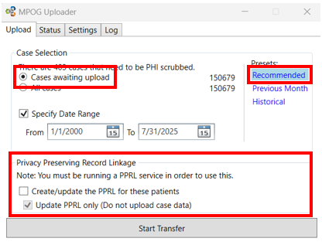

**If you are experiencing errors when transferring older data, you can uncheck the box next to ‘Create/update the blinded record index for this patient.’

What do the presets include?
There are three presets for transferring to MPOG – Recommended, Previous Month, and Historical. You do not need to specify a date range when using these presets, it will automatically populate when you choose a setting.
- Recommended – This setting includes cases for the previous month and any historical cases that have been updated (i.e., mapping changes, new billing data, or new data that wasn’t included previously). Use this for your regular monthly transfers. This setting could contain a lot of data and may take some time to complete.
- Previous Month – This setting only includes data for the previous month. Use this if you are short on time for your regular monthly transfer, as this setting contains only one month of data. Any older cases that have new data or mapping changes will not be sent to MPOG Central and will not be updated. You will need to complete a Historical (see below) transfer when you have time in order to update the older data.
- Historical - This setting only includes your historical data and does not include the previous month. Use this if you have historical data that needs to be updated at MPOG Central outside of the monthly upload schedule. This transfer can take some time, as it includes any historical cases that either have new data or have updated mapping. You can transfer historical data any time throughout the month.

*If your site receives Provider Feedback Emails, you must use either the Recommended setting or the Previous Month setting to transfer data before the monthly deadline. Historical data is not reflected in those emails but is used in the QI Reporting Tool (Dashboard) measure scores.

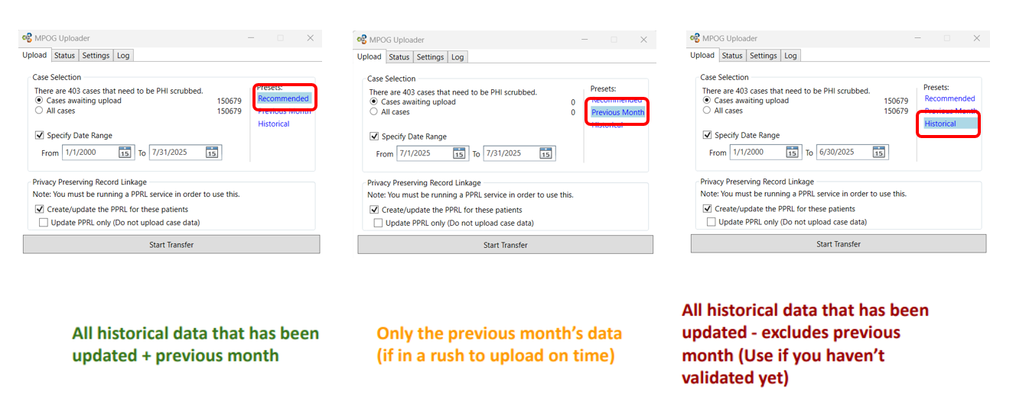

Maintenance Schedule

What is the Maintenance Schedule?
The Maintenance Schedule is the recommended cadence to complete monthly tasks, and to ensure that data is uploaded by the deadline. Tasks are broken down into which week they should be completed during. Week 1 is the first week of the month with a Wednesday.
It also includes dates for the monthly data transfer deadline, and dates for when Provider Feedback Emails will be sent.

It also includes the dates of the Transfer Deadline, QI Reporting Tool (Dashboard) Update, and when Provider Feedback Emails will be sent.

When should data be uploaded?
Data is uploaded for the previous month on the 3rd Wednesday. This gives enough time for the data to process so we can send Provider Feedback Emails on the 4th Wednesday.

**The only exception is in December, where the transfer deadline is the 2nd Wednesday and Provider Feedback Emails are sent on the 3rd Wednesday.

Where can I find it?
The maintenance schedule is under the Resources page under the Quality section on the MPOG website, https://mpog.org/

How often is it updated?
It is updated every year and is typically available on the MPOG website starting in November or December.

Upgrades

When is the MPOG App Suite Upgraded?
The MPOG App Suite is upgraded twice per year, in the spring and in the fall. There are two parts to each upgrade: the database upgrade and the app (workstation) upgrade. The database upgrade is completed with assistance from the MPOG Technical team. The app (workstation) upgrade is the part that you see in the MPOG App Suite. There are different ways to apply the app upgrade, depending on your site. Your technical team will give you instructions when it is time.

How do we apply the upgrade?
The upgrade package will be sent to each site’s IT contact.
- For sites using Desktop Virtualization (e.g., Citrix), your IT team will upgrade the App Suite.
- For sites where the App Suite is installed on PCs, your IT team will distribute the installer to all individuals after the database upgrade has been applied. Once you have received the installer from your IT team, follow the install instructions here.

Can we skip an upgrade?
No, you cannot skip an upgrade. Often, the changes made during one upgrade are built upon changes made during previous upgrades.

Can I submit a request for an upgrade?
Yes, if you have a request that you would like included in a future MPOG App Suite upgrade, contact the MPOG help desk (support@mpog.zendesk.com) with your request.

Appendix A – Database Roles

The following table shows the database roles needed for access to the applications within the MPOG Suite. No additional permissions are needed to use these applications.
Please grant MPOG_Researcher to everyone who needs to use the MPOG Suite. It acts as a base role.
 | Case Viewer | Concept Browser | Variable Mapping¹ | STS Import² | NSQIP Import² | PHI Scrubber | Data Diagnostics | Case Validation | Transfer to MPOG Central | Batch MRN Lookup | Content Synchronization | Research Data Cleaning³ | Location Mapping | Provider Contacts | Import Manager Assistant⁴
MPOG_AssistantApp |  |  |  |  |  |  |  |  |  |  |  |  |  |  | ✓
MPOG_CaseValidator | ✓ | ✓ |  |  |  |  | ✓ | ✓ |  | ✓ |  |  |  | ✓
MPOG_ContentDownloader |  |  |  | ✓ | ✓ |  |  |  |  |  | ✓
MPOG_Exporter |  |  |  |  |  | ✓ |  |  | ✓ |  |  |  |  | ✓
MPOG_ExporterRestricted |  |  |  |  |  |  |  |  | ✓
MPOG_Importer | ✓ | ✓ | ✓ | ✓ | ✓ | ✓ | ✓ | ✓ |  | ✓ |  |  | ✓
MPOG_MRNBatcher |  |  |  |  |  |  |  |  |  | ✓
MPOG_PhiScrubber |  |  |  |  |  | ✓
MPOG_QueryWriter
MPOG_Researcher | ✓ | ✓ |  |  |  |  | ✓ |  |  |  |  | ✓
MPOG_VariableMapper |  | ✓ | ✓ |  |  |  |  |  |  |  |  |  | ✓
db_owner | ✓ | ✓ | ✓ | ✓ | ✓ | ✓ | ✓ | ✓ | ✓ | ✓ | ✓ | ✓ | ✓ | ✓ | ✓

¹ A config connection is required for this application unless the configuration type is Epic Legacy.
² Either db_owner or both MPOG_Importer and MPOG_ContentDownloader is required to use the registry import applications (NSQIP and STS). Just MPOG_ContentDownloader or MPOG_Importer will not be enough to use either of these applications.
³ A research connection is required for this application.
⁴ This application is only available for Import Manager configurations.

Last updated May 7, 2019

Appendix B – MPOG Role Assignments

What credentials are required for fulfilling the different roles for MPOG Participation?

Role/Task | Credentials | Responsibilities | Notes
IT Lead |  | Oversees the development, maintenance, and optimization of the IT infrastructure supporting MPOG's diverse initiatives. This role involves managing a team of IT professionals, ensuring data security and integrity, coordinating with clinical teams, and implementing technology solutions to facilitate efficient data collection, analysis, and reporting.
IT Support |  | Responsible for providing technical assistance and troubleshooting for systems used in local sites efforts with MPOG initiatives. | Can also help with Data Uploader role.
Anesthesia IT Champion | Anesthesiologist | Works with the local technical and clinical teams to assist with implementing the IT infrastructure necessary to support MPOG participation. This role requires an understanding of concept mapping and local EHR documentation. | The Quality Champion, PI, and IT Champion roles can be fulfilled by one individual or multiple. We defer to the institution to determine who will be best suited for each role.
Quality Champion | Anesthesiologist | Participates in the MPOG Quality Committee on behalf of the site. They are responsible for reviewing site performance on MPOG QI measures and disseminating best practices locally | The Quality Champion, PI, and IT Champion roles can be fulfilled by one individual or multiple. We defer to the institution to determine who will be best suited for each role.
Principal Investigator | Anesthesiologist | Leads research efforts for the site and participate in the MPOG Perioperative Clinical Research Committee (PCRC). | The Quality Champion, PI, and IT Champion roles can be fulfilled by one individual or multiple. We defer to the institution to determine who will be best suited for each role.
Role/Task | Credentials | Responsibilities | Notes
Cardiac Champion | Anesthesiologist | Expert in cardiac anesthesia who leads efforts to improve cardiac care and outcomes within MPOG. This role involves advocating for best practices, analyzing performance metrics, guiding quality improvement initiatives, and collaborating with both clinical and technical teams to implement evidence-based protocols and contribute to MPOG's research efforts in cardiac anesthesia.
OB Champion | Anesthesiologist | An expert in obstetric anesthesia who leads initiatives to improve care quality and outcomes for pregnant patients. This role involves advocating for best practices, analyzing performance metrics, guiding quality improvement projects, and collaborating with clinical and technical teams to implement evidence-based protocols and contribute to MPOG's research efforts in obstetric anesthesia.
Pediatric Chair |  | Pediatric Chair at local site who oversees initiatives aimed at improving care quality and outcomes for pediatric patients. This role involves setting clinical guidelines, analyzing performance data, driving quality improvement projects, and collaborating with multidisciplinary teams to implement evidence-based practices, while also contributing to MPOG's broader research and educational goals in pediatric anesthesia.
Role/Task | Credentials | Responsibilities | Notes
Pediatric Champion | Anesthesiologist | Expert in pediatric anesthesia dedicated to enhancing the quality and outcomes of care for pediatric patients. This role involves advocating for best practices, analyzing performance metrics, leading quality improvement initiatives, and collaborating with clinical and technical teams to implement evidence-based protocols that align with MPOG's research and quality improvement goals in pediatric anesthesia.
Variable Mapper | Anesthesiologist, CRNA, Anesthesia Assistant, RN | Responsible for accurately mapping local electronic health record (EHR) data to MPOG's standardized variables. This role requires a deep understanding of both local EHR documentation and MPOG's data definitions, ensuring data integrity and consistency to support meaningful research and quality improvement efforts. The Variable Mapper should be someone with clinical experience (Anesthesiologist, CRNA, RN, etc.). | Michigan sites have an RN or CRNA in this position. Sites outside Michigan will have either their technical support, Anesthesia IT Champion, or Quality Champion fill this role.  Although not recommended, this role can be filled by someone without clinical experience (i.e., IT Lead), as long as they have a clinical person to help as needed
Location Mapper | Any | This person should have a working knowledge of the site’s campus (i.e., OR rooms, Non-OR Areas, etc.) | Michigan sites have an RN or CRNA in this position. Sites outside Michigan will have either their technical support, Anesthesia IT Champion, or Quality Champion fill this role.
Case Validator | Anesthesiologist, CRNA, Anesthesia Assistant, RN | Completes Case Validations prior to monthly Transfer to MPOG. Current requirements are to complete a minimum of 5 validations per month. | Michigan sites have an RN or CRNA in this position. Sites outside Michigan will have either their Anesthesia IT Champion or Quality Champion fill this role.
Role/Task | Credentials | Responsibilities | Notes
Data Uploader (PHI Scrub and Transfer to MPOG) | Any | Responsible for the timely and accurate upload of clinical data to the MPOG database. This role entails managing data extraction from local electronic health records, ensuring data quality, and troubleshooting any issues that arise during the upload process to support the ongoing research and quality improvement initiatives within the organization. | Michigan sites have an RN or CRNA in this position. Sites outside Michigan will have either their technical support, Anesthesia IT Champion, or Quality Champion fill this role.
Data Diagnostics Reviewer | Anesthesiologist, CRNA, Anesthesia Assistant, RN | Prior to monthly Transfer to MPOG, completes Review and Attestation of Data Diagnostics for accuracy. Works with site’s IT Support to troubleshoot issues. | Michigan sites have an RN or CRNA in this position. Sites outside Michigan will have either their Anesthesia IT Champion or Quality Champion fill this role.
Provider Contacts Management |  |  | Michigan sites have an RN or CRNA in this position. Sites outside Michigan will have either their technical support, Anesthesia IT Champion, or Quality Champion fill this role.
Anesthesia Clinical Quality Reviewer (ACQR) | RN or CRNA | ASPIRE is the quality improvement (QI) arm of the MPOG, that improves outcomes by empowering perioperative teams to explore variation in practice and identify opportunities for change. Funding provided by Blue Cross Blue Shield of Michigan (BCBSM) supports ASPIRE activities within the state of Michigan and requires each site to hire an ACQR. The ACQR’s primary function is to facilitate the implementation of the ASPIRE program within their institution.

Glossary

ACQR – Anesthesia Clinical Quality Reviewer. This is a role that is required for institutions participating in MPOG/ASPIRE within the State of Michigan. Institutions will receive yearly funding for the ACQR. This role is typically filled by a Registered Nurse with operating room experience but can be filled by other clinical staff (i.e., CRNA). The ACQR’s primary function is to facilitate the implementation of the ASPIRE program within their institution. Funding for the ACQR is based on annual case volumes.
AIMS – Anesthesia Information Management System
AIMS Variables – These are the variables that are found in the site’s EHR. The variable names are assigned in the extract.
ASPIRE – The Anesthesiology Performance Improvement and Reporting Exchange (ASPIRE) is the quality improvement (QI) arm of the Multicenter Perioperative Outcomes Group (MPOG). ASPIRE improves outcomes by empowering perioperative teams to explore variation in practice and identify opportunities for change.
Blinded Record Index (BRI) – A system that creates a blinded record index by merging datasets across sites without PHI. It uses a hashing algorithm that is encrypted and cannot be decrypted. This was now referred to as Privacy Preserving Record Linkage (PPRL). The name is changed, but the process is the same.
Consume – Files stored within the Import Manager Database are parsed into tabular data and inserted into staging tables. Additionally, metadata regarding variable usage is generated for later mapping.
Extract – Files are generated by extracting data from its source system (i.e., Epic, Cerner, CompuRecord, etc.). These files are then placed into a file share accessible by the MPOG import utility. The site technical team completes this process. Epic has a standard MPOG Extract that they use for their sites. All other EHRs require the site technical team to write their own MPOG Extract.
Funded Sites – Sites participating in MPOG that are located within the State of Michigan (USA) that also participate in the ASPIRE CQI. These sites receive funding from Blue Cross Blue Shield of Michigan and must meet specific yearly requirements.
Handoff – The tabular data is inserted into the designated LOCAL MPOG_MAS database. The data within this database is accessible to the clinical team through the MPOG App Suite (Workstation). After this step, you will see the data in the different tools of the MPOG App Suite – Variable Mapping, Case Viewer, Case Validation, Data Diagnostics.
Import – Files are removed from the file share and inserted directly into the Import Manager Database, which is located on the site’s LOCAL MPOG Database Server.
MPOG – The Multicenter Perioperative Outcomes Group
Non-Funded sites – Sites participating in MPOG that are located outside the State of Michigan (USA).

Privacy Preserving Record Linkage (PPRL) - A system that creates a blinded record index by merging datasets across sites without PHI. It uses a hashing algorithm that is encrypted and cannot be decrypted. This was previously referred to as Blinded Record Index (BRI). The name is changed, but the process is the same.
Transfer to MPOG – Using the transfer utility within the MPOG application suite, surgical cases are uploaded to the central repository. This step is completed by the designated person (i.e., ACQR, QI Champion, technical team member), and is completed AFTER data has been validated, PHI Scrubbed and attested. This step transfers the data from the Local MPOG Database to the Central MPOG Database.
Upload – Using the transfer utility within the MPOG application suite, surgical cases are uploaded to the central repository. This step is completed by the designated person (i.e., ACQR, QI Champion, technical team member), and is completed AFTER data has been validated, PHI Scrubbed and attested. This step transfers the data from the Local MPOG Database to the Central MPOG Database.
Variable Mapping - This process of standardizing terms across multiple EHRs and across multiple sites allows for common data elements to be used for research or quality improvement purposes. Think of this as the process of translating the site’s AIMS Variables into the same language as all other MPOG Sites (i.e., Clinician is the same thing as Anesthesiologist). The Variable Mapper should be someone with clinical experience (Anesthesiologist, CRNA, RN, etc.). Although not recommended, this role can be filled by someone without clinical experience (i.e., IT Lead), as long as they have a clinical person to help as needed.

