|  |  |
| --- | --- |
| Title of Study or Project: | *Please limit Cover Sheet to one page.* |
| Primary Institution: |  |
| Primary Author: |  |
| Co-Authors: | *Please consider defining co-authors at* *time of* *presentation.*  *Further info:* [*Preparing Your MPOG Manuscript*](https://mpog.org/preparing-your-mpog-manuscript-2/) *Requirements*: [*ICMJE requirements for co-authorship*](http://www.icmje.org/recommendations/browse/roles-and-responsibilities/defining-the-role-of-authors-and-contributors.html) |
| Statistician(s): | *Please note, if statisticians are seeking access to case-level data to execute the proposed analysis, they must have a primary appointment (i.e. non-adjunct/affiliate faculty appointment) at the active MPOG site for which the IRB is obtained.* |
| Type of Study: | << Exploratory / Retrospective Observational / Prospective Trial >> |
| Data Source(s): | << MPOG Database / Surgical Registry (e.g. STS, NSQIP) / Other (describe) >> |
| IRB Number/Status: | <<IRB Number>> / <<Approved / Pending>>  ☐ NOTE: IRB *must* specify that dataset is a *limited dataset* (i.e., not de-identified) |
| Hypotheses / Aims: | *Tip*: *review* [*Tips & Tricks Modules*](https://mpog.org/tipsandtricks/) *on the MPOG website:*   * *“****MPOG Research Process Overview****”* * *“****Developing a Research Proposal****”* |
| Number of Patients/Participants: |  |
| Power Analysis: |  |
| Proposed statistical tests/analyses: |  |
| Resources (Brief summary of resources for data collection, personnel, financial): |  |

**\*\*STOP \*\***

*Before investing the substantial time to develop the rest of this proposal, please submit the Cover Sheet to the MPOG Coordinating Center via the ‘****Research Consultation Form,’*** *as detailed in Step 2 of the MPOG website --> Research --> “*[*Research Proposal Process*](https://mpog.org/write-a-research-proposal/)*” .*

Submission of the Cover Sheet enables the MPOG Central Research Team to provide early feedback on your project idea, in its formative stages, in order to:

1. ensure feasibility;
2. identify potential collaborators across MPOG who are developing similar projects;
3. position your project for maximal chance of successful publication in a high-impact journal.

Please note, successful completion of an MPOG project typically requires an integrated team-based scientific approach with:

* ***Clinical subject matter expertise*** (usually with a primary medical qualification and perioperative clinical practice insight), and
* ***Statistical methods expertise*** (usually with doctoral level training and experience in public health science, e.g. biostatistics, epidemiology)

Please consider seeking collaboration from those with complementary expertise to ensure these skills are reflected in your study team.

The MPOG Central Research team is committed to your success!

# Introduction*(target 300-500 words; limit 750 words)*

*Tip: consider writing the Introduction and Methods, exactly as intended for submission to target journal (links to Instructions for Authors can be found here:* [*Anesthesiology*](http://anesthesiology.pubs.asahq.org/public/instructionsforauthors.aspx)*,* [*BJA*](https://www.elsevier.com/journals/british-journal-of-anaesthesia/0007-0912/guide-for-authors)*,* [*JAMA*](https://jamanetwork.com/journals/jama/pages/instructions-for-authors)*,* [*A&A*](https://journals.lww.com/anesthesia-analgesia/_layouts/15/1033/oaks.journals/informationforauthors.aspx)*).*

*The introduction should cover:*

* What is the **significance** of the clinical problem being addressed?
* What **current gaps** exist in the understanding of this problem?
* How will this project **address this gap** and advance clinical care and/or research knowledge?
* What are the primary (and secondary if applicable) **aim(s) / hypothes(es)**?

# Methods

*Tip: review* [*Tips & Tricks Module*](https://mpog.org/tipsandtricks/) *on the MPOG website: “****Developing a Research Question Answerable with MPOG Data****”*

**Study Design**

Please include:

* Type of study (e.g. exploratory, retrospective, prospective, etc.)
* IRB approval/pending approval statement
* Reporting Guidelines: Please review the [EQUATOR Network](https://www.equator-network.org/reporting-guidelines/) and determine the appropriate guidelines for reporting your proposal and that your proposal is in accordance with the checklist. Common examples include:
  + Observational studies using routinely collected EHR data (i.e., MPOG data) - RECORD extension of the STROBE guidelines
  + Clinical prediction or diagnostic models - TRIPOD guidelines
  + Systematic reviews and meta-analysis - PRISMA guidelines
  + Quality Improvement Studies - SQUIRE guidelines

**Study Population**

*Tip: review* [*Tips & Tricks Module*](https://mpog.org/tipsandtricks/) *on the MPOG website: “****Using DataDirect for Self-Serve Data Access****”*

Text to include:

* Date range
* Participating institutions (or selection criteria for institutions)
  + Please state whether non-US institutions should be included in study, versus US institutions only
* Study population
  + **Inclusion criteria** – Which cases/patients are included in the dataset that you will receive (e.g., certain timeframes, procedures, ages). Some notes*:*
    - Start dates earlier than Jan 1st, 2015 have less consistent data quality compared to more recent dates.
    - End dates later than 3 months before the current date may have lower rates of data completeness.
    - Consider using a pre-defined starting population, such as “Intraoperative Research Standard” or “Outcome Research Standard”; see [MPOG DataDirect](https://mpog.org/tools) for details.
  + **Exclusion/Screening criteria** – Those criteria your team will want to use to exclude/screen cases from the dataset you receive, as part of your analysis processes. For example, if you list “Outpatient Procedures” as an *exclusion* criterion, your dataset will still include outpatient procedure cases *and* will include the variable(s) needed for your analyst to remove these cases from analyses when desired.
* Estimated sample size, as determined by [MPOG DataDirect](https://mpog.org/tools) query using Cohort mode, or preliminary query of any other data source involved.

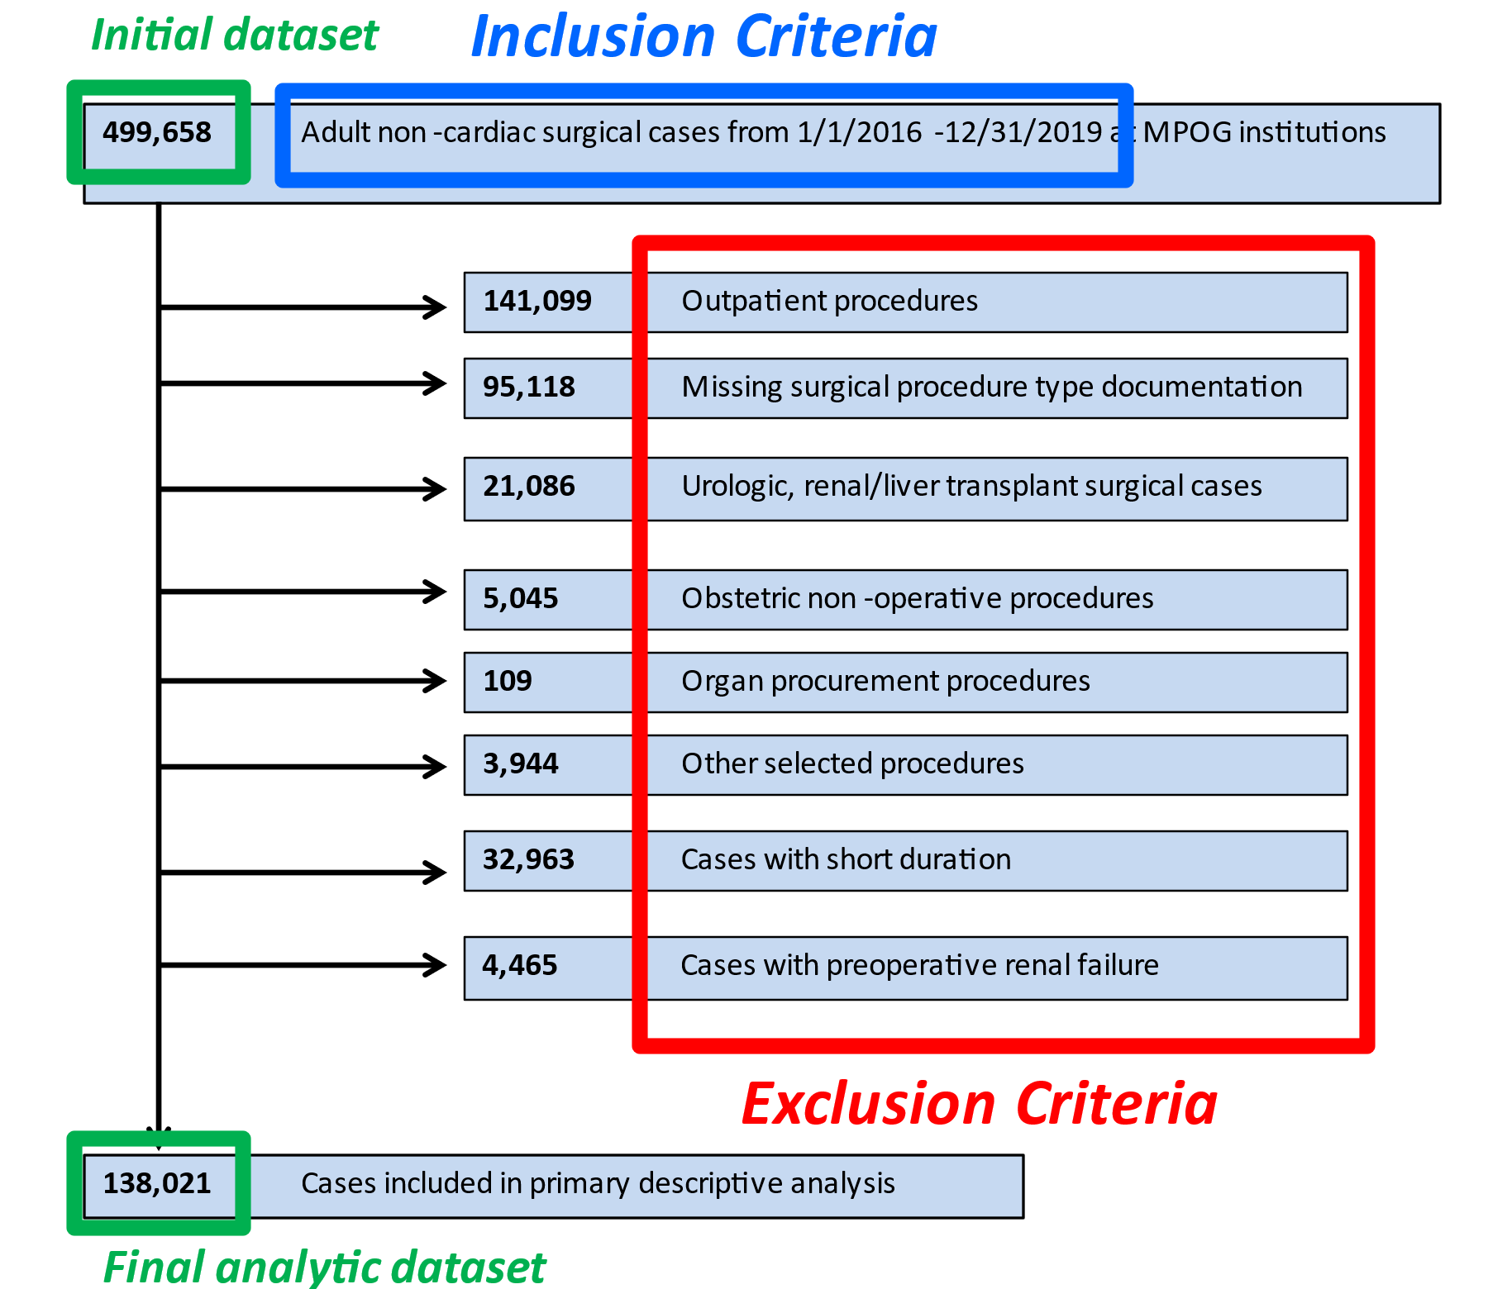

**Illustrative Example Figure:** Demonstration of Inclusions vs. Exclusions,

and Initial Dataset received from MPOG Central vs. Final Analytic Dataset that study team creates

Data source

Text indicating which data source(s) you anticipate using for your analysis. Please be as specific as possible.

* For the vast majority of PCRC proposals, stating “MPOG database” is sufficient for this section
* If you anticipate using other data sources, please state how you propose to link them to the pooled, Limited MPOG dataset.

Primary outcome

Text to clearly define the primary outcome.

Note: Occasionally, PCRC proposals may have 2-3 aims, although each proposal is intended to correspond to one manuscript. For proposals with 2-3 aims, please clearly identify which outcomes / exposures / covariates / statistical analyses / power analyses correspond to each aim.

For proposals exceeding the scope of 2-3 aims, please consider developing separate PCRC proposals, or discussing with the MPOG Coordinating Center.

Secondary outcome(s), if applicable

Text to define any secondary outcomes

Exposure Variable

Text to include a description of the exposure variable of interest

* Please provide as specific a definition as possible
* For exposure variables previously studied, consider providing references justifying your choice of definition

Covariates

*Tip:* *Review the* [*Tips & Tricks Module*](https://mpog.org/tipsandtricks/) *on the MPOG website, “****Transforming Raw Data into Clinical Inferences: Phenotypes****”*

Text to describe the relevant, specific covariates to the study and their derived parameters. To promote generalizability and comparison to other studies, please consider using [MPOG Phenotypes](https://phenotypes.mpog.org/) to develop the covariate list.

* Consider using a simple table
* Please be specific—i.e. stating “comorbidities” is not sufficient, instead list “[Elixhauser Comorbidity – Cardiac Arrhythmias](https://phenotypes.mpog.org/Elixhauser%20Comorbidity%20-%20Cardiac%20Arrhythmias)”, “[Elixhauser Comorbidity – Peripheral Vascular Disorders](https://phenotypes.mpog.org/Elixhauser%20Comorbidity%20-%20Peripheral%20Vascular%20Disorders)”, etc.
* If using terms which lack a generally agreed-upon definition (e.g., intraoperative hypotension), please define what criteria you would use to define this event (e.g., an artifact-reduced, de-duplicated [MPOG Blood Pressure Observation](https://phenotypes.mpog.org/Blood%20Pressure%20Observations) with mean arterial pressure <65 mmHg for greater than 10 cumulative minutes between [Case Start](https://phenotypes.mpog.org/Case%20Start) and [Case End](https://phenotypes.mpog.org/case%20end))
* All covariates described should be consistent with what the study team specifies in the Query Specification.

Statistical analysis

*Tip*: *Review the* [*Tips & Tricks Module*](https://mpog.org/tipsandtricks/) *on the MPOG website: “****Statistics for Large Database Research****”*

*Note: A rigorous pre-specified Statistical Analysis Plan is required. Descriptions such as “statistical analyses will be performed”, “will be done by statistician”, etc. are not adequate. Please consult with a statistician for assistance in completing this section if necessary. The importance of a pre-specified analytic plan is discussed in* [*Reporting of Observational Research in Anesthesiology: The Importance of the Analysis Plan*](https://pubs.asahq.org/anesthesiology/article/124/5/998/14371/Reporting-of-Observational-Research-in)*.*

Please consider the following (where applicable):

* Proposed statistical software to be used
* Partitioning of cohorts (e.g. derivation/validation, if applicable)
* Specific univariate testing (e.g. Student’s t-test, Mann-Whitney U test)
* Specific multivariable testing (e.g. logistic / linear regression)
  + *Fixed effects versus mixed effects models*: if developing a multivariable model, consider MPOG institution as a random effect in a mixed effects model
  + *Multi-level modelling*: Consider a nesting structure within the data analyzed, e.g. cases within anesthesiologists within institutions
* Methods for assessing and handling collinearity (e.g. variance inflation factor, Pearson correlations)
* Threshold for significance
  + For studies with extremely large sample sizes (e.g., >50,000) and event rates, consider a strong p-value (e.g. p <0.01 or <0.005) rather than traditional p <0.05
  + Report confidence intervals with widths equivalent to the specified p-value
  + As an alternative to p-values, consider using absolute standardized differences
  + For studies with multiple independent tests performed, consider a method to control for multiple comparisons (e.g. Bonferroni correction, Benjamini-Hochberg procedure)
* Methods for performing internal and external validation
  + Internal validation – e.g. bootstrapping, leave-one-out (LOO) cross-validation
  + External validation – e.g. model performance within validation cohort
* Methods for assessing effect size (e.g. adjusted odds ratios, confidence intervals)
* When applicable, consider a strategy for handling baseline differences between cases/patients with and without the exposure of interest
* When applicable, consider methods for model/variable selection
* Alternative designs may include Bayesian approaches:
  + Describe how prior distributions will be selected
  + Choose the width and type of credible intervals (highest density vs equal tail)
  + Report the probability of direction and the region of practical equivalence for parameter estimates
  + Consider sensitivity analysis to study impact of varying prior selections on posterior distributions
  + Pre-specified Sensitivity / Subgroup / Secondary outcome analyses (optional)

Text to include:

* Description of sensitivity analyses (if performed)
* Description of subgroup analyses of the study population (if performed)
* Description of analyses of secondary outcomes (if performed)

Power analysis

Text to include description of power analysis (required for primary outcome):

* Please consult your team’s statistician for assistance in completing this section.
* Please include your a priori estimation of what constitutes a clinically meaningful effect size, and the sample size necessary to detect such an effect size.
  + Example: “For purposes of this study, we considered a reduction in complication rates from 20% to 10% to be a clinically meaningful exposure. At a power level of 80%, we determined 4,958 patients would be necessary to detect such a reduction, at a significance level α = 0.05.”

Handling of missing, invalid, or extreme value data

*For the exposure and outcome variables, please describe how you will define and handle artifacts, abnormal/extreme or missing values.*

MPOG data comes from EHR data, which can contain errors that are transferred to MPOG and not identified as invalid prior to data being distributed to study teams. Please describe how your team plans to identify and handle potentially invalid data values.

For MPOG studies, common methods for handling missing data include a complete case analysis, and/or multiple imputation.

* A summary of these techniques[*is provided here*](https://www.ncbi.nlm.nih.gov/pmc/articles/PMC3668100/)*.*

Major Threats to Inference & Mitigation Strategies

* Please describe the major threats to inference that may affect your proposed analysis and your plan to mitigate these threats.
* ***Threats to inference*** could include:
  + Confounders unavailable within MPOG dataset (or other datasets used)
  + Lack of generalizability due to the unique patient population selected
  + Information bias arising from systematic differences in EHR documentation patterns across institutions, time, or other subgroups within the dataset
  + Bias introduced by confounders, mediators, and colliders (illustrative examples below)

Acute Lung Injury-Specific Illustrative Examples of Confounders, Mediators, and Colliders

* Consider 2-3 ***mitigation strategies*** which could include (*but are not limited to)*:
  + Additional statistical analyses not used in main analysis:
    - [Instrumental variable](https://www.sciencedirect.com/topics/medicine-and-dentistry/instrumental-variable-analysis) analyses
    - Natural experiments (e.g. [difference-in-differences](https://www.sciencedirect.com/topics/economics-econometrics-and-finance/difference-in-differences), [regression discontinuity](https://www.sciencedirect.com/topics/economics-econometrics-and-finance/regression-discontinuity-design))
    - Covariate balancing methods (e.g. propensity scores)
    - [Targeted maximum likelihood estimators](https://towardsdatascience.com/targeted-maximum-likelihood-tmle-for-causal-inference-1be88542a749) (TMLEs)
    - Mixed effects models
    - Sensitivity analyses with other definitions of exposure or outcome variables, with expected biases in *opposite directions from the hypothesized threats to inference*
    - Subgroup analyses with restrictive exclusion criteria (if adequate study power) to eliminate impact of unmeasured confounders
  + [Target trial emulation](https://academic.oup.com/aje/article/183/8/758/1739860) study design
  + Use of a ***causal diagram*** to optimize the study design (example figure below)
    - [Anesthesiology Reader’s Toolbox article here](https://pubs.asahq.org/anesthesiology/article/132/5/951/108969/An-Introduction-to-Causal-Diagrams-for)
    - [Causal diagram software here](http://www.dagitty.net/) (although could be a Powerpoint figure)

**Figure: Illustrative Examples of Causal Diagrams.**

[**Anesthesiology. 2020;132(5):951-967. doi:10.1097/ALN.0000000000003193**](https://pubs.asahq.org/anesthesiology/article/132/5/951/108969/An-Introduction-to-Causal-Diagrams-for) **(Figure 4)**

Preliminary Data Analyses

* Please provide results of preliminary data analyses from your institution, used to support the key assumptions underlying the choice of exposures and outcomes in the study.
* It may be helpful and appropriate to provide the results of a single center investigation which uses similar methods to demonstrate the efficacy of your proposed project
* Preliminary data analyses usually include:
  + Summary statistics of your local institution’s *single-center* data (available via download from DataDirect once completing the MPOG DataDirect Security Checklist and Authorization Form) for key exposure variables, covariates, and outcomes
  + Case counts of MPOG’s *multicenter* data (available using Cohort Mode within DataDirect).
    - Note, sharing multicenter data counts beyond this proposal requires PCRC approval. Data must not be shared publicly (e.g. journal publication, conference abstract, invited talk, social media) prior to receiving this approval.
* Please describe any obstacles encountered with the quality of a test dataset obtained from DataDirect, and what strategies you plan to use to mitigate these obstacles.

Areas for discussion / Known Limitations

* If applicable, include several points that you wish to discuss at the PCRC meeting.
* This will help MPOG reviewers provide targeted feedback regarding questions/concerns you may already have with the proposed manuscript.
* Additionally, you may wish to acknowledge known limitations to your proposed study (e.g. retrospective observational nature, limitations to EHR-derived data quality, etc.)

**References**

*Please provide references to support the proposal, cited in-line with the text above and similar to how references will be presented in a manuscript.*

**Query Specification**

*Tip*: *Review* [*Tips & Tricks Module*](https://mpog.org/tipsandtricks/) *on the MPOG website: “****Using DataDirect for Self-Serve Data Access****”*

* Please develop a query specification form, which enables the MPOG developer team to provide the necessary data for analysis of the research proposal.
* Please use the [MPOG query specification template](https://mpog.org/files/research/MPOG%20Query%20Spec%20Template.xlsx)
* These query specification forms include:
  + Data elements to determine inclusion criteria (as would be used to describe the initial set of eligible patients within a flow diagram)
  + Data elements comprising the final analytic dataset including exclusion criteria, exposure variables, outcome variables, and covariates
* Please provide the MPOG DataDirect Query ID with the PCRC Proposal Submission Checklist

# Reporting Guidelines Checklist

Please review the [EQUATOR Network](https://www.equator-network.org/reporting-guidelines/), determine the appropriate guidelines for reporting your proposal, use the checklist associated with those guidelines. Common examples include:

* Routinely collected EHR data (MPOG data) - RECORD extension of STROBE guidelines
* Clinical prediction or diagnostic models - TRIPOD guidelines
* Quality Improvement Studies - SQUIRE guidelines

For convenience, the most common checklist for MPOG studies – the RECORD extension of the STROBE guidelines – is listed below, but please replace with the appropriate checklist if needed.

|  |  |  |  |  |  |
| --- | --- | --- | --- | --- | --- |
|  | **Item No.** | **STROBE items** | **Page #** | **RECORD items** | **Page #** |
| **Title and abstract** | | | | | | |
|  | 1 | (a) Indicate the study’s design with a commonly used term in the title or the abstract (b) Provide in the abstract an informative and balanced summary of what was done and what was found |  | RECORD 1.1: The type of data used should be specified in the title or abstract. When possible, the name of the databases used should be included.  RECORD 1.2: If applicable, the geographic region and timeframe within which the study took place should be reported in the title or abstract.  RECORD 1.3: If linkage between databases was conducted for the study, this should be clearly stated in the title or abstract. |  |
| **Introduction** | | | | | | |
| Background rationale | 2 | Explain the scientific background and rationale for the investigation being reported |  |  |  |
| Objectives | 3 | State specific objectives, including any prespecified hypotheses |  |  |  |
| **Methods** | | | | | | |
| Study Design | 4 | Present key elements of study design early in the paper |  |  |  |
| Setting | 5 | Describe the setting, locations, and relevant dates, including periods of recruitment, exposure, follow-up, and data collection |  |  |  |
| Participants | 6 | *(a) Cohort study* - Give the eligibility criteria, and the sources and methods of selection of participants. Describe methods of follow-up  *Case-control study* - Give the eligibility criteria, and the sources and methods of case ascertainment and control selection. Give the rationale for the choice of cases and controls  *Cross-sectional study* - Give the eligibility criteria, and the sources and methods of selection of participants  *(b) Cohort study* - For matched studies, give matching criteria and number of exposed and unexposed  *Case-control study* - For matched studies, give matching criteria and the number of controls per case |  | RECORD 6.1: The methods of study population selection (such as codes or algorithms used to identify subjects) should be listed in detail. If this is not possible, an explanation should be provided.  RECORD 6.2: Any validation studies of the codes or algorithms used to select the population should be referenced. If validation was conducted for this study and not published elsewhere, detailed methods and results should be provided.  RECORD 6.3: If the study involved linkage of databases, consider use of a flow diagram or other graphical display to demonstrate the data linkage process, including the number of individuals with linked data at each stage. |  |
| Variables | 7 | Clearly define all outcomes, exposures, predictors, potential confounders, and effect modifiers. Give diagnostic criteria, if applicable. |  | RECORD 7.1: A complete list of codes and algorithms used to classify exposures, outcomes, confounders, and effect modifiers should be provided. If these cannot be reported, an explanation should be provided. |  |
| Data sources/ measurement | 8 | For each variable of interest, give sources of data and details of methods of assessment (measurement).  Describe comparability of assessment methods if there is more than one group |  |  |  |
| Bias | 9 | Describe any efforts to address potential sources of bias |  |  |  |
| Study size | 10 | Explain how the study size was arrived at |  |  |  |
| Quantitative variables | 11 | Explain how quantitative variables were handled in the analyses. If applicable, describe which groupings were chosen, and why |  |  |  |
| Statistical methods | 12 | (a) Describe all statistical methods, including those used to control for confounding  (b) Describe any methods used to examine subgroups and interactions  (c) Explain how missing data were addressed  (d) *Cohort study* - If applicable, explain how loss to follow-up was addressed  *Case-control study* - If applicable, explain how matching of cases and controls was addressed  *Cross-sectional study* - If applicable, describe analytical methods taking account of sampling strategy  (e) Describe any sensitivity analyses |  |  |  |
| Data access and cleaning methods |  | .. |  | RECORD 12.1: Authors should describe the extent to which the investigators had access to the database population used to create the study population.  RECORD 12.2: Authors should provide information on the data cleaning methods used in the study. |  |
| Linkage |  | .. |  | RECORD 12.3: State whether the study included person-level, institutional-level, or other data linkage across two or more databases. The methods of linkage and methods of linkage quality evaluation should be provided. |  |
| **Results** | | | | | | |
| Participants | 13 | (a) Report the numbers of individuals at each stage of the study (*e.g.*, numbers potentially eligible, examined for eligibility, confirmed eligible, included in the study, completing follow-up, and analysed)  (b) Give reasons for non-participation at each stage.  (c) Consider use of a flow diagram | ***N/A for PCRC*** | RECORD 13.1: Describe in detail the selection of the persons included in the study (*i.e.,* study population selection) including filtering based on data quality, data availability and linkage. The selection of included persons can be described in the text and/or by means of the study flow diagram. | ***N/A for PCRC*** |
| Descriptive data | 14 | (a) Give characteristics of study participants (*e.g.*, demographic, clinical, social) and information on exposures and potential confounders  (b) Indicate the number of participants with missing data for each variable of interest  (c) *Cohort study* - summarise follow-up time (*e.g.*, average and total amount) | ***N/A for PCRC*** |  | ***N/A for PCRC*** |
| Outcome data | 15 | *Cohort study* - Report numbers of outcome events or summary measures over time  *Case-control study* - Report numbers in each exposure category, or summary measures of exposure  *Cross-sectional study* - Report numbers of outcome events or summary measures | ***N/A for PCRC*** |  | ***N/A for PCRC*** |
| Main results | 16 | (a) Give unadjusted estimates and, if applicable, confounder-adjusted estimates and their precision (e.g., 95% confidence interval). Make clear which confounders were adjusted for and why they were included  (b) Report category boundaries when continuous variables were categorized  (c) If relevant, consider translating estimates of relative risk into absolute risk for a meaningful time period | ***N/A for PCRC*** |  | ***N/A for PCRC*** |
| Other analyses | 17 | Report other analyses done—e.g., analyses of subgroups and interactions, and sensitivity analyses | ***N/A for PCRC*** |  | ***N/A for PCRC*** |
| **Discussion** | | | | | | |
| Key results | 18 | Summarize key results with reference to study objectives | ***N/A for PCRC*** |  | ***N/A for PCRC*** |
| Limitations | 19 | Discuss limitations of the study, taking into account sources of potential bias or imprecision. Discuss both direction and magnitude of any potential bias |  | RECORD 19.1: Discuss the implications of using data that were not created or collected to answer the specific research question(s). Include discussion of misclassification bias, unmeasured confounding, missing data, and changing eligibility over time, as they pertain to the study being reported. |  |
| Interpretation | 20 | Give a cautious overall interpretation of results considering objectives, limitations, multiplicity of analyses, results from similar studies, and other relevant evidence | ***N/A for PCRC*** |  | ***N/A for PCRC*** |
| Generalisability | 21 | Discuss the generalisability (external validity) of the study results | ***N/A for PCRC*** |  | ***N/A for PCRC*** |
| **Other Information** | | | | | | |
| Funding | 22 | Give the source of funding and the role of the funders for the present study and, if applicable, for the original study on which the present article is based |  |  |  |
| Accessibility of protocol, raw data, and programming code |  | .. |  | RECORD 22.1: Authors should provide information on how to access any supplemental information such as the study protocol, raw data, or programming code. |  |