Anesthesiology Performance Improvement and Reporting Exchange (ASPIRE)
Quality Committee Meeting Notes – Monday, July 28, 2014 and Friday, September 1, 2014

Attendees: P=Present; A=Absent; X=Expected Absence
A | Abdallah, Arbi ‘Ben’ (Wash U) | A | Lirk, Philipp (AMC)
7/28 | Agarwala, Aalok (MGH) | A | Madden, Lawrence (Mercy Muskegon)
A | Aziz, Michael (OHSU) | A | Martin, Matt (Munson)
A | Becker, Aimee (Wisconsin) | A | Morey, Timothy (Florida)
7/28 | Bell, Genevieve (Michigan) | 7/28 | Naik, Bhiken (Virginia)
A | Berman, Mitch (Columbia) | A | Noles, Michael (OHSU)
7/28 | Biggs, Daniel (Oklahoma) | 7/28 | O’Donnell, Steve (Vermont)
A | Bonifer, Thomas (Allegiance) | 8/1 | Pasma, Weize (Utrecht)
7/28 & 8/1 | Buehler, Katie (A4) | 7/28 | Pace, Nathan (Utah
A | Cuff, Germaine (NYU Langone) | 8/1 | Pagenelli, William (Vermont)
7/28 & 8/1 | Dehring, Mark (Michigan) | A | Price, Matthew (Beaumont)
A | Domino, Karen (Washington) | 7/28 | Ramachandran, Satya Krishna (Michigan)
7/28 | Eastman, Jaime (OHSU) | A | Robinowicz, David (UCSF)
8/1 | Epps, Jerry, (Tennessee) | 8/1 | St. Jacques, Paul (Vanderbilt)
7/28 | Fleisher, Lee (Pennsylania) | 7/28 | Segal, Scott (Tufts)
A | Fleishut, Peter (Weill Cornell) | 7/28 & 8/1 | Shah, Nirav (Michigan)
8/1 | Jameson, Leslie (Colorado) | A | Sharma, Anshuman (Wash U)
8/1 | Kappen, Teus (Utrecht) | A | Simon, Tom (NYU Langone)
7/28 & 8/1 | Kheterpal, Sachin (Michigan) | A | Smith, Jeffrey (McLaren)
8/1 | Kooij, Fabian (AMC) | A | Sommer, Richard (NYU Langone)
7/28 | Kuhl, Mackenzie (Marquette) | 8/1 | Soto, Roy (Beaumont)
7/28 & 8/1 | Lacca, Tory (Michigan) | 7/28 | Stefanich, Lyle (Oklahoma)
A | Lagasse, Robert (Yale) | 7/28 | Tocco-Bradley, Rosalie (St. Joseph)
A | LaGorio, John (Mercy Muskegon) | A | Wedeven, Chris (Holland Hospital)
7/28 | Levy, Warren (Pennsylvania) | 7/28 | Wilczak, Janet (Oakwood)

Purpose of the QI Committee
- Forum for MPOG members to discuss and nominate quality measures important to their practice/hospital
- Review and validate measure details/exclusion criteria/thresholds
- Provide feedback on tools
- Forum to ask for help on MPOG content development – SAMBA extract
Opening Review
- Describe/agree on purpose of the calls
  - Attendance on the call includes
    - Current MPOG members
    - New MPOG members
    - Future MPOG members (practices in the State of Michigan that are part of the QI expansion)
    - Reflects a broader group of anesthesiologists including academic and private practice
  - Forum for all sites to discuss and nominate quality measures
    - Gaining wide acceptance
    - Apply it to software and dashboards
    - Bi-directional conversation
    - Feedback on the utility
    - Assistance with content development
  - What value are we providing on measures we are creating
    - Define the unique delivery mechanism
      - Benchmarking value
      - Provider specific value
      - User interface value

- Overview of dashboards (see Appendix A)
  - Third party tool
    - Data is housed at U of M central repository
    - Have control over user interface
    - Data is under our control and how we see it
  - Three levels of feedback
    - Chairperson / head of practice
    - Comparison (provider / institutional)
    - Provider level feedback
  - Should we have provider names on the reports so everyone can see them or should only the chair / head of practice be able to see the names?
    - Some institutions make the names available and some do not
    - We will provide a filter, so that each institution can set their preferences
  - The dashboards are color coded based on thresholds that will defined by the committee
    - The green, yellow and red are applied across all facilities and will be defined by the international thresholds. We will chose measure we agree upon.
  - Will we be using national benchmarks?
    - We can use national benchmarks, but not all measures have a national benchmark. We need to address where we establish the thresholds. We created a document to determine thresholds and we want to discuss these as a group to come to a consensus of what thresholds to use.
  - Is it possible to add trends?
    - Yes, we will add those to the dashboards
  - How will we deal with a combination of the in-room provider (faculty, resident or CRNA)?
    - Currently the dashboards are set up to the display the attending
    - For each measure who do you attribute when you have multiple attendings?
      - Each measure need a high level of detail to reflect appropriate attending
      - It is important to separate out the coverage so providers can see their own data for comparison, otherwise they will not utilize the dashboards
      - One of the filters can be ‘who were you supervising?’ with these options:
        - I was in the room alone
        - I was supervising a resident
        - I was supervising a CRNA
  - Provider Performance needs to be easy for providers to use. The goal is to devise a system that will be used by a lot of providers to help stimulate change.
    - Make sure the provider information is accurate, because if it is not then the providers will not use it
    - Is it possible to track logins?
      - We are not sure and will have to discuss this with the vendor
      - You can make whether someone logged in a metric
  - Create smaller focus groups to define look and feel (navigation)
  - Do we want to give individuals exposure to the data?
    - Head of QI should be the point person and can disseminate the information to their colleagues
  - Individual provider dashboard will provide information on the measures and how the measures were derived.
    - Distributing features/functionality to the individual level and allow them to use it and ‘buy into’ the process to see how they compare.
  - Will we be able to look into outcomes data for providers? How do we normalize the surgical insult? For example, one surgeon takes four hours to complete a case vs. another who take two on the exact same procedure.
    - Make a filter that we define duration
    - Make the measure normalized to time
    - Many will include this in the inclusion/exclusion criteria

- Review QI measures
  - Measure to review
    - Process of care
      - Externally established metrics (SCIP, etc.)
      - Internally developed
    - Clinical outcomes
    - Exploratory
  - Limited to 4-6 measures per year and we need to determine the most important measures so we are ready in January.
    - Are you going to condense this large list down to only five-six measures?
      - This list is limited by our ability to come to agreement on the definitions and thresholds. If we can agree upon more than five, we will add more.
      - If we pick five, we want to look at measures that impact patient outcomes
        - Glucose management
        - Reintubation
      - We need to focus on the process measures not the outcome measures, because the quality of the data may not be good enough for outcome measures
  - Would it help to consolidate the 10 – 15 measures and send them out for a vote?
    - Yes, this would be helpful, but send out the measures for comments first
    - Send out a survey for committee members to vote and determine the validity of the measures
  - Is there a measure for escalation of care?
    - We need to create that category and have focused on SCIP measures and those we are currently being measured on in our practice
    - If we go after rare events, do we have thresholds for those? Does this add value and do we want to benchmark ourselves?
  - One of the goals is that during the implementation of the quality measures some of the methods you have been able to gain compliance at your individual institutions can be shared with the group.
Discussion
- There is a struggle to get useful feedback from AQI, will this define what we get back from AQI?
  - We are a small fraction of anesthesiologists and we will focus on high quality EHR sites. Because there is a lot of data validation then we will have higher quality data. We are a subset of AQI database and will be separate.
- We recommend that we serve as a test-bed for measures. We need to drive measures instead of reacting to them. As a subset of AQI with high quality data we can assist in driving the quality measures. Quality starts when an individual sees they are doing something wrong and changes their practice.
- We will have Dr. Pace work with Amy to help look at the statistical analysis for the reports
- A forum will be created on the website to discuss measures.

Appendix A:
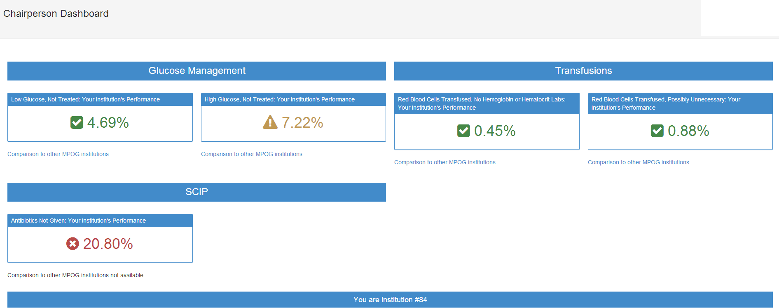

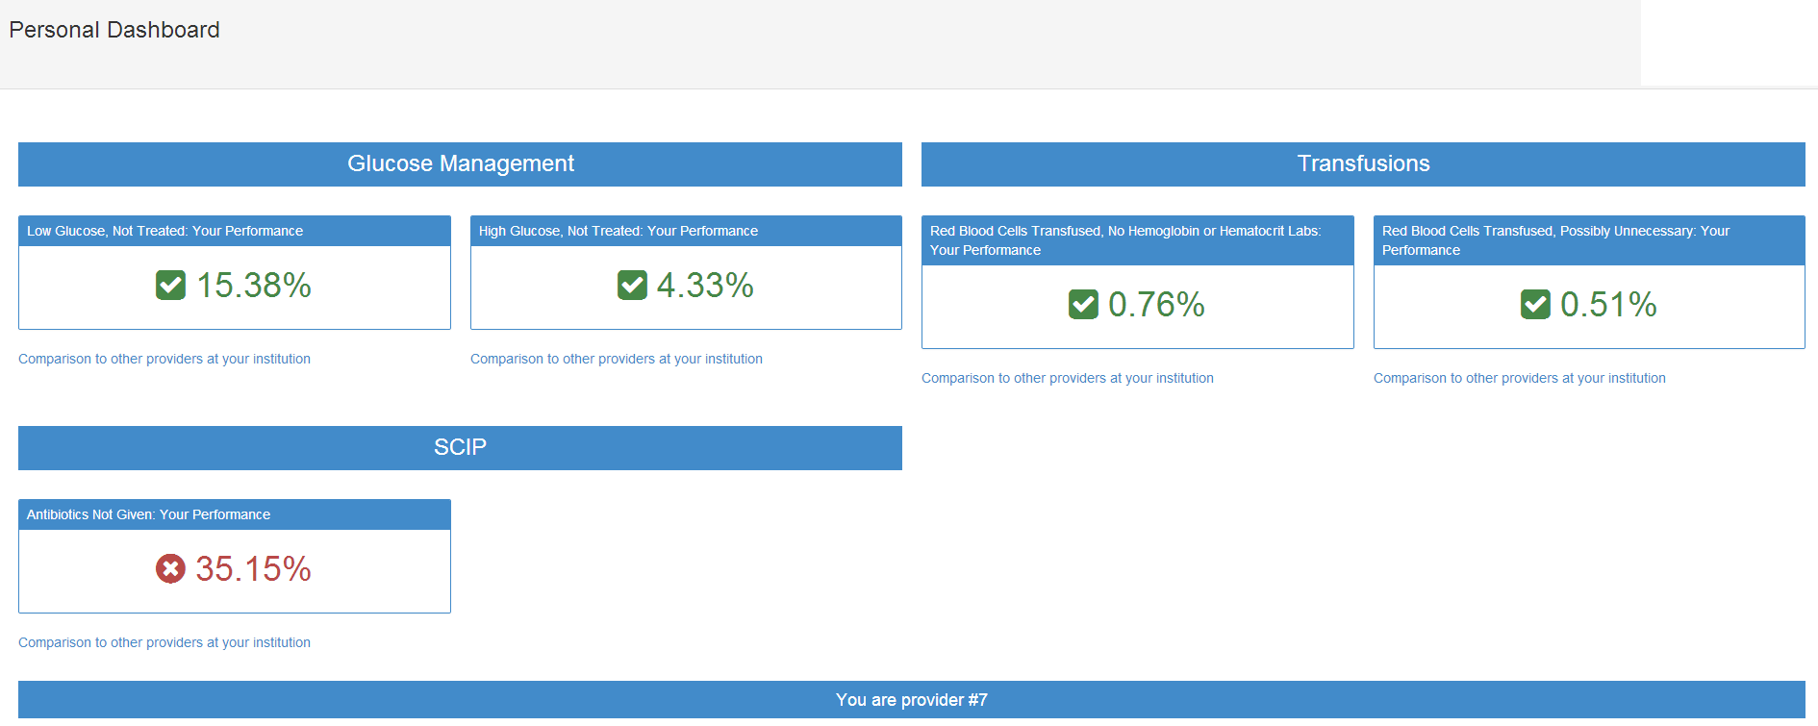
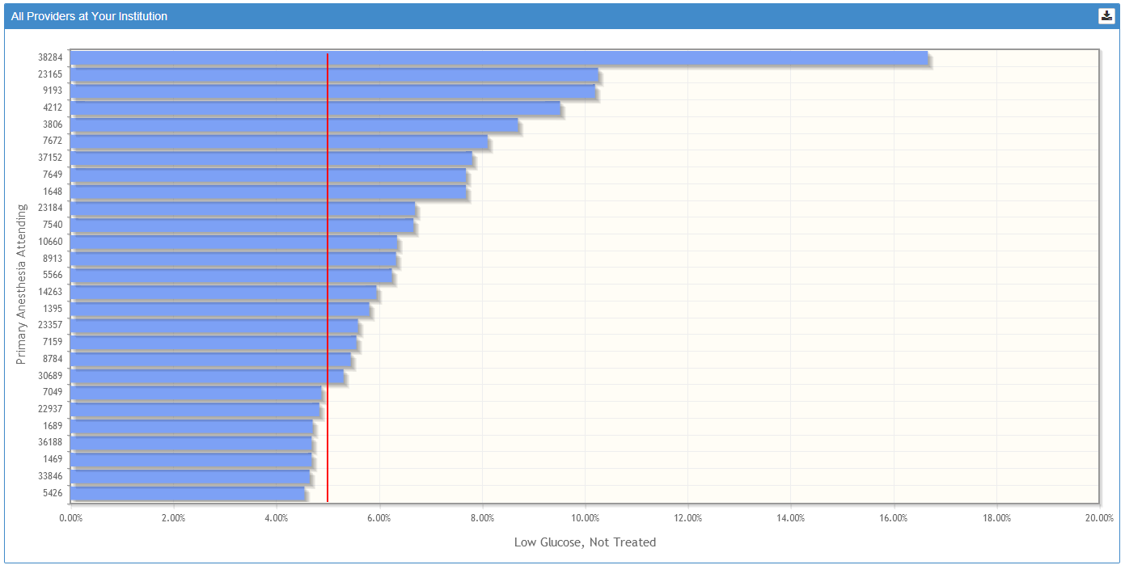
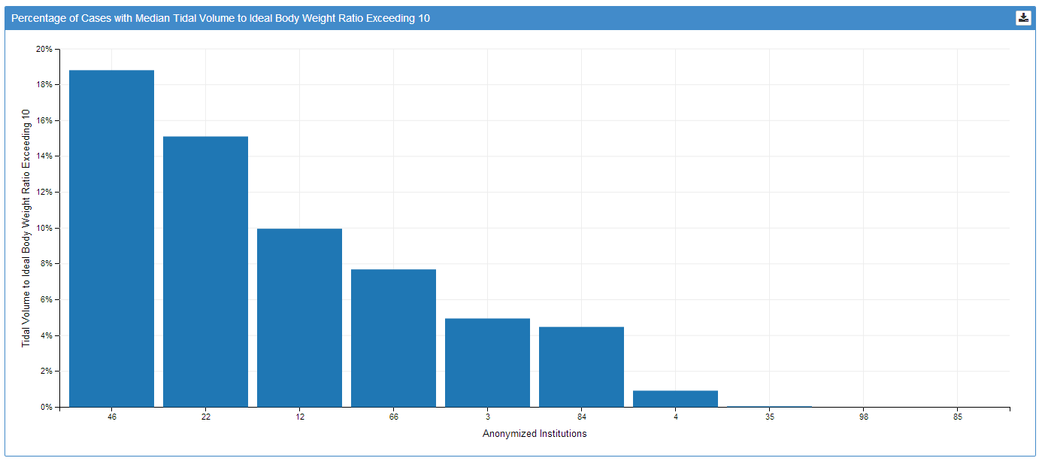
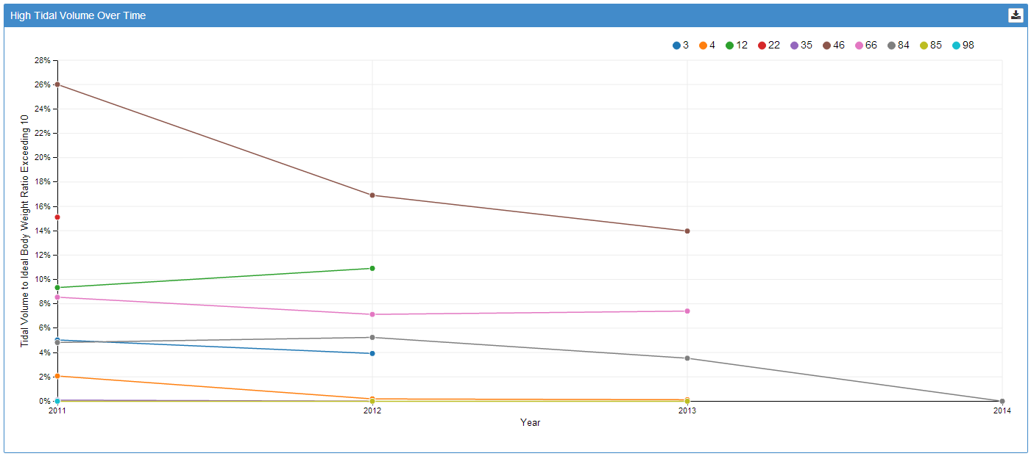

Appendix B:

Proposed QI Reports v2014
The QI reports are divided into three major domains:
- Process of care
  - Externally established metrics (SCIP, etc)
  - Internally developed
- Clinical outcome
- Exploratory
Due to the relative lack of NQF-endorsed perioperative measures applicable to the anesthesiology provider, many QI reports are based upon commonly accepted clinical practices developed by the MPOG member institution representatives. There are two basic dashboards made available: departmental and provider. The departmental dashboard is exposed to departmental or institution leadership and enabled cross-center comparison with drill-down into individual (anonymized) providers. The provider dashboard is designed for each individual clinician to review their own performance within centers. Reports can be filtered by primary surgical procedure or primary ICD9 procedure code. For all current measures, ASA 5 or 6 patients are excluded, as are procedures with < 45 minutes of anesthesia time (start to end). Currently, all measures are designed for use with adult patient populations only.

Process of care -- SCIP
- SCIP-INF1 – Timing of prophylactic antibiotics
- SCIP-INF10 – Perioperative normothermia and warming
- SCIP-CARD2 – Continuation of beta-blockade in patients with chronic beta blockade therapy

Process of care -- Internally developed
- Intraoperative neuromuscular blockade monitoring and treatment
  - Exclusions
    - Patients arriving to operating room intubated or transported directly to ICU
  - Measures
    - Proportion of patients receiving a non-depolarizing neuromuscular blockade medication with documentation of neuromuscular function recovery (TOF twitches)
    - Proportion of patients receiving a non-depolarizing neuromuscular blockade medication with administration of neostigmine if time from last administration to extubation is < 4 half-lives (specific to drug administered)
  - Threshold
    - 95%
- Monitoring vigilance
  - Exclusions
    - Emergency patients
  - Measures
    - Proportion of patients without a 10 minute gap in systolic or mean arterial pressure between patient in room and patient out of room
  - Threshold
    - 95%
- Discretionary transfusion management
  - Exclusions
    - Patients with >=4 units of intraoperative PRBC transfused
    - EBL >= 2000 ML
    - Outpatient surgery
  - Measures
    - Patients receiving PRBC at all
    - Patients receiving PRBC at all with a measured and documented hematocrit or hemoglobin within 60 minutes
    - Patients receiving PRBC with a first post anesthesia end (within 6 hours) hematocrit > 32.0
    - Intraoperative hematocrit or hemoglobin nadir
  - Thresholds
    - In development
- Glucose management
  - Exclusions
    - Pancreatic transplants
  - Measures
    - Patients with perioperative glucose > 250 (between anesthesia start-2 hours and anesthesia end + 2 hours) with an insulin bolus or infusion or glucose recheck
    - Patients with insulin given (between anesthesia start and anesthesia end), recheck within 120 minutes (anesthesia end + 2 hours)
    - Patients with glucose < 60 (between anesthesia start-2 hours and anesthesia end) with a glucose recheck of treatment with dextrose containing solution (between anesthesia start and anesthesia end + 2 hours)
- Intraoperative ventilator management
  - Exclusions
    - Patients arriving to operating room intubated or transported directly to ICU
    - Outpatient surgery
    - Patients without an endotracheal intubation during procedure
  - Measures
    - Patients without sustained intraoperative tidal volume > 10 ml/kg ideal body weight for 10 continuous minutes or greater
    - Patients without sustained intraoperative tidal volume > 10 ml/kg ideal body weight for 20 minutes or greater
  - Thresholds
    - In development
- Fluid management
  - Exclusions
    - Patients with >=4 units of intraoperative PRBC transfused
    - EBL >= 2000 ML
    - Outpatient surgery
    - Prone surgery > 4 hours anesthesia time
    - Any surgery > 8 hours anesthesia time
  - Measures
    - Patients without administration of albumin (5%, 25%, 10%) between anesthesia start and end
    - Patients without administration of hetastarch, pentastarch, or voluven between anesthesia start and end
  - Thresholds
    - 85%
- Postoperative nausea and vomiting prophylaxis in patients undergoing general anesthetic with inhalational anesthesia
  - Exclusions
    - Non-general anesthetic
    - General anesthetic without use of inhalational anesthetic
    - Fewer than 3 risk factors for PONV (female gender, non smoker, PONV/motion sickness history, opiate administration)
  - Measure
    - Patients with administration of 2 or more classes of antiemetics between anesthesia start-6 hours to anesthesia end (5HT3 antagonist, steroids, phenothiazine, IM ephedrine, butyrophenone, antihistamine, or anticholinergic)
  - Thresholds
    - 95%

Clinical outcome
- Medication overdosing
  - Exclusions
    - Electroconvulsive therapy patients
  - Measures
    - Any patient receiving any dose of naloxone
    - Any patient receiving any dose of flumazenil
  - Thresholds
    - 0
- End organ damage or failure
  - Exclusions
    - Arrived to OR intubated
    - Serum Troponin-I measured within 60 days prior to anesthesia start
    - Baseline serum creatinine > 4.0 within 60 days prior to anesthesia start
  - Measures
    - Reintubated in recovery room or operating room
    - Postoperative troponin-I > 1.00 within 4 postoperative days
    - Postoperative Stage I, kidney injury (KDIGO criteria)
      - 1.5 x baseline serum creatinine (measured within 60 preoperative days) observed in first 7 postoperative days
      - 0.3 mg/dl rise in creatinine within 48 hours
  - Thresholds
    - In development
- Pain management
  - Exclusions
    - Any patient with baseline preoperative pain score >=2 (on VAS scale 1 – 10)
  - Measure
    - Peak pain score in recovery <= 5
    - Peak pain score in recovery <= 8
  - Thresholds
    - In development

Exploratory variation in care analyses
- Anesthesia technique
  - Patients with an arterial line
  - Patients with a central venous catheter
  - Patients receiving a general anesthetic
  - Patients receiving a Peripheral nerve block
  - Patients receiving an epidural
  - Patients receiving a spinal
  - Patients receiving a spinal and a GA

